Dartmouth Patients’ Working Group: Who’s Who
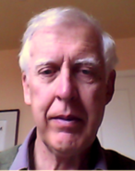
Chair: Pierre Landell-Mills moved to Dartmouth in 2001. He is an economist who has worked for 50 years in the field of development, living in Africa and Bangladesh for a part of that time. He now works as a consultant on political economy. He has been a staunch supporter of the Flavel. He may be reached by email at info@dartmouthpatients.org.uk .
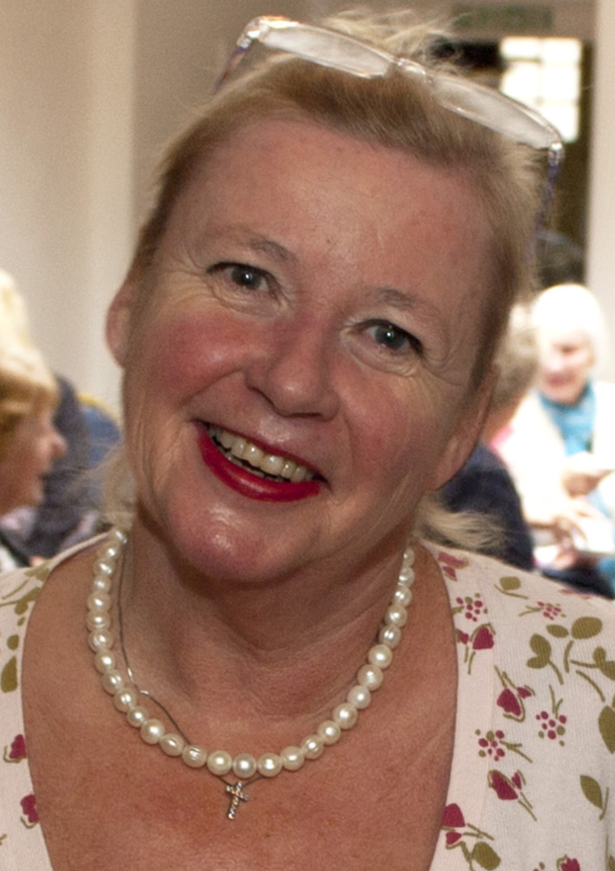
Vice-chair: Dee Nutt moved to Dartmouth in1998 and became a member of the Independent Monitoring Board at Exeter Prison with responsibilities for healthcare. She also became a member on the Home office committee on Diversity. In 2006 she became chair of Dartmouth Caring a small charity, which works in partnership with the medical practice concentrating on the elderly and vulnerable in the community. She feels all have a right to a voice and PPGs can facilitate that with members being that voice. To contact her email deenutt@btinternet.com .

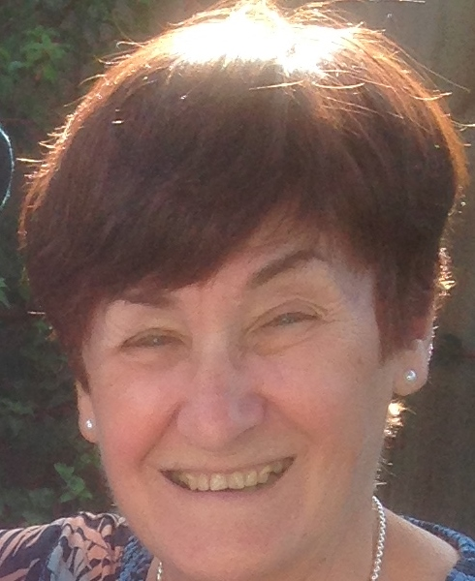
Hilary Atkinson moved to Stoke Fleming 8 years ago, having just retired from working for 25 years in a GP practice near Bristol where she became Practice Manager. She hopes that through her experience she may be able to be of some help to the PPG. Her contact email is hilary-atkinson@hotmail.co.uk
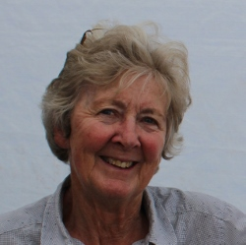
Liane Baldock lived Africa and South America for 25 years with her geologist husband. She moved to Strete in 2003. She has 3 sons and 6 grandchildren, her youngest son dying in 2014 from a totally unexpected heart attack. Her interest lies in getting better diagnosis of this in men of 40 and over; also in medical research, in particular cancer and diagnostic scans. Her contact email is john_liane@btinternet.com

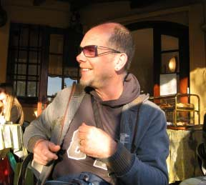
John Donaldson lives in Blackawton. Painting and music have been competing
but now increasingly complimentary passions in John's life. His
contact email is john@johndonaldsonpaintings.com

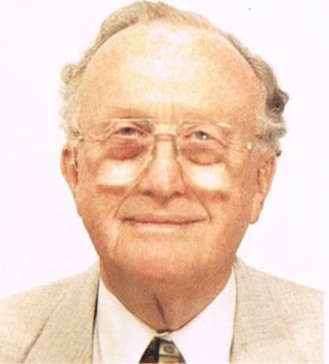
Alister Gill retired to Dartmouth in 1986 following a career in the pharmaceutical industry. He has since served as a member of the Torbay Health Authority, has been a Mental Health Act Manager and had other pharmaceutical involvements. He has a daughter who is a teacher and a son who is a GP. He will try to maintain a continued awareness of the needs of
Dartmouth patients and further the objectives of the PPG. His contact email is
alistergill@talktalk.net.

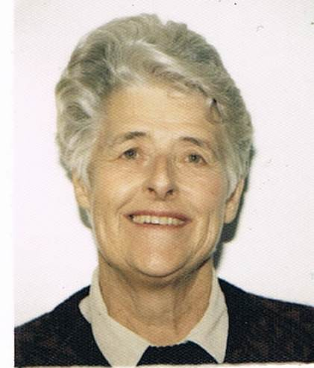
Diana Knight is a retired NHS consultant neurophysiologist with experience in hospital management. She has wide range of interests including sailing and gardening. Having owned a house in Dartmouth for nearly 30 years, she moved to Stoke Fleming in 2010. “I joined the PPG as I believe it is a valuable forum where patients’ opinions can be heard to help with the development
and delivery of NHS services”. She can be contacted at dinight1@btinternet.com

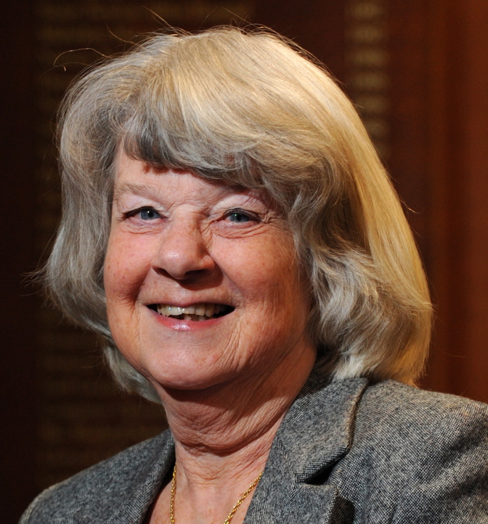
Anne Harvey has a background in business computing. She has lived in Blackawton for more than 20 years and for six of these served as its parish clerk. Since 2007 she has been a governor of South Devon Healthcare NHS Foundation Trust, our local acute hospital in Torbay, and for four years was its Lead Governor. Her contact email is clyston@waitrose.com.
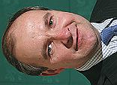
Jonathan Hawkins is on the Devon County Council and South Hams
District Council and is a local business man. He cares very much about his local community, and has worked over a number of years to help achieve
its aspirations. His contact email is jhawkins@devon.gov.uk.

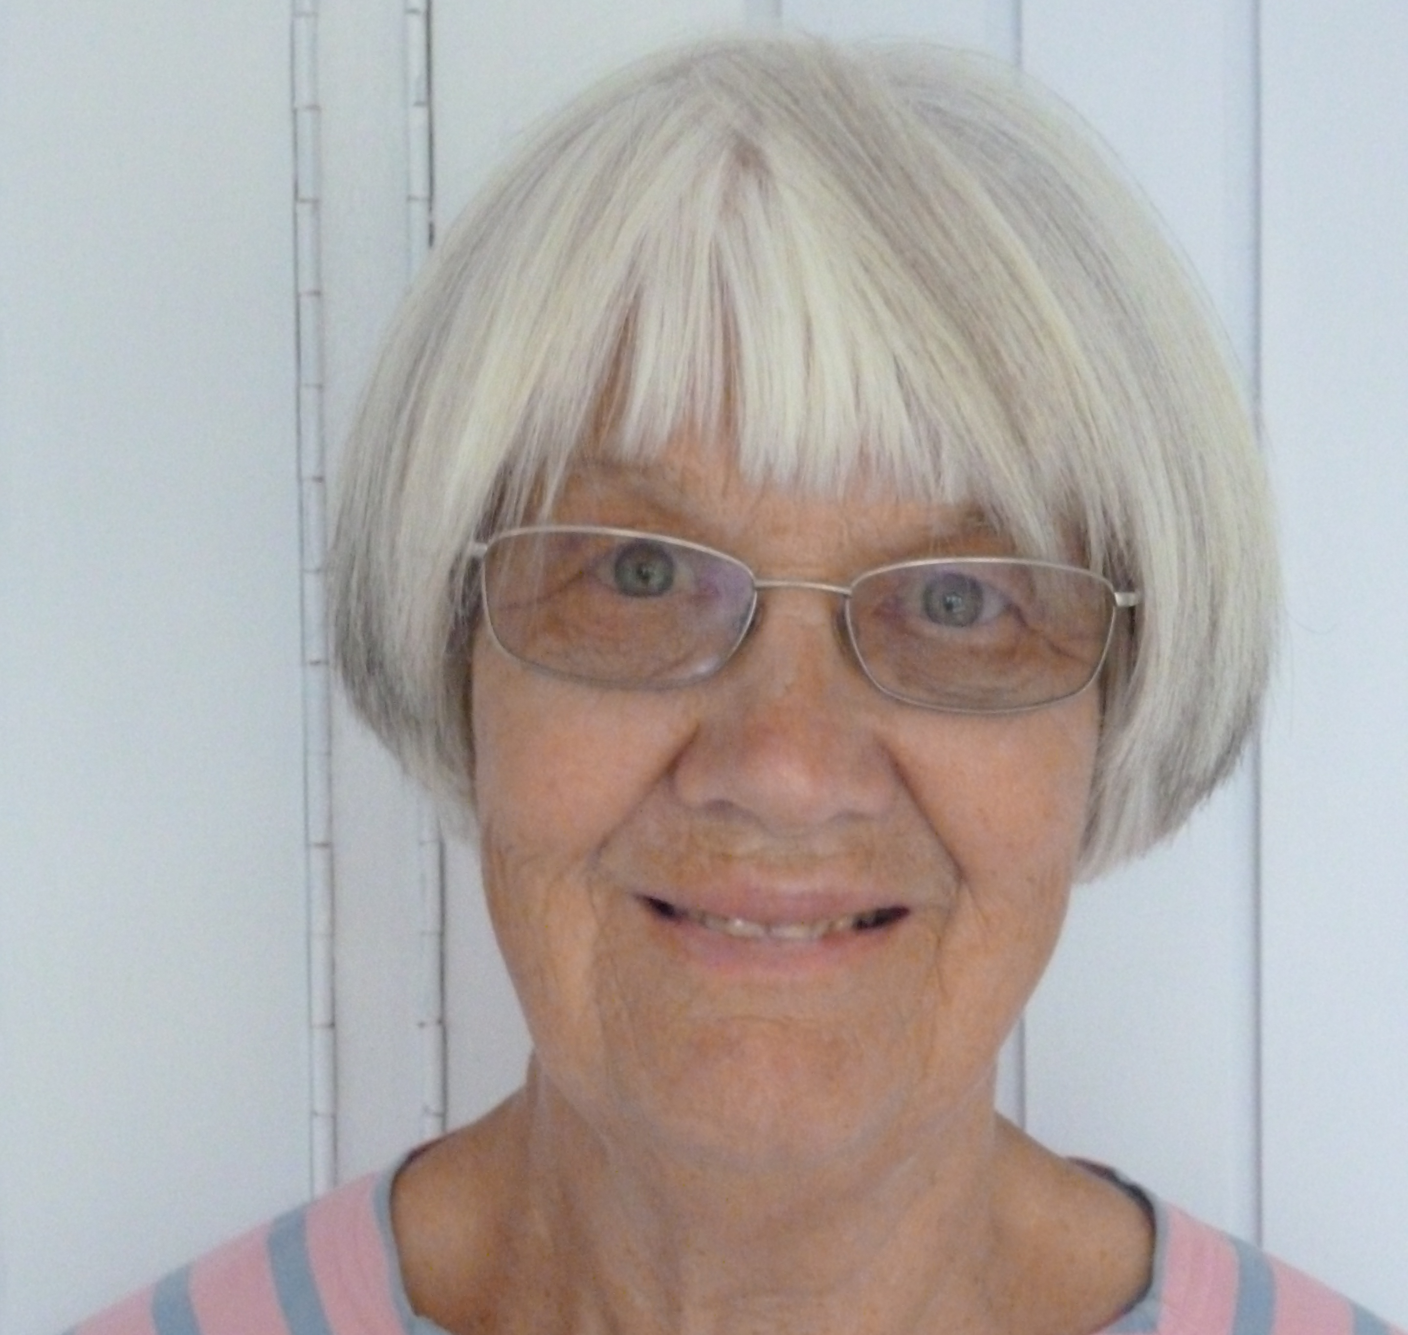
Jane Hattersley is the daughter of a GP and was brought up with the surgery and waiting room within our house. She trained as a nurse at St Thomes' Hospital, later took a degree in Biology and Health Science followed by a diploma in Medical Ethics. My last job was as Research Sister. She has lived in Dartmouth for 16 years. She may be contacted on janemhatt@gmail.com

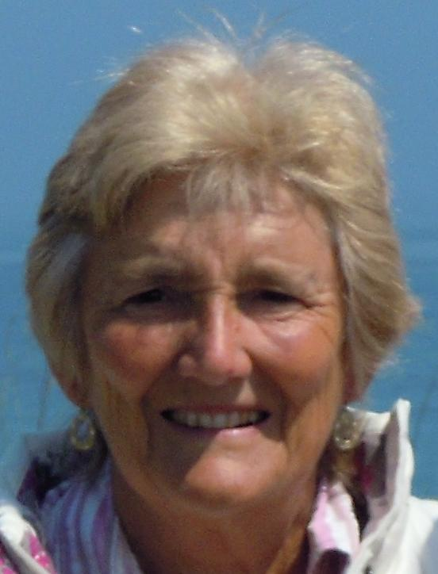
Carol Lingard has lived in Dartmouth on and off since 1977. She is married with two sons. She worked for many years as a physiotherapist at Dartmouth Hospital, retiring in 2006. She has been heavily involved with the Dartmouth Museum and is also Chair of Dartmouth Hospital League of Friends. She was recently appointed Chair of the Devon Association of Leagues of Friends. Carol’s contact email is dmhl@msn.com .

Janice Mathews

Iain McCall lives in Dartmouth and is a retired consultant
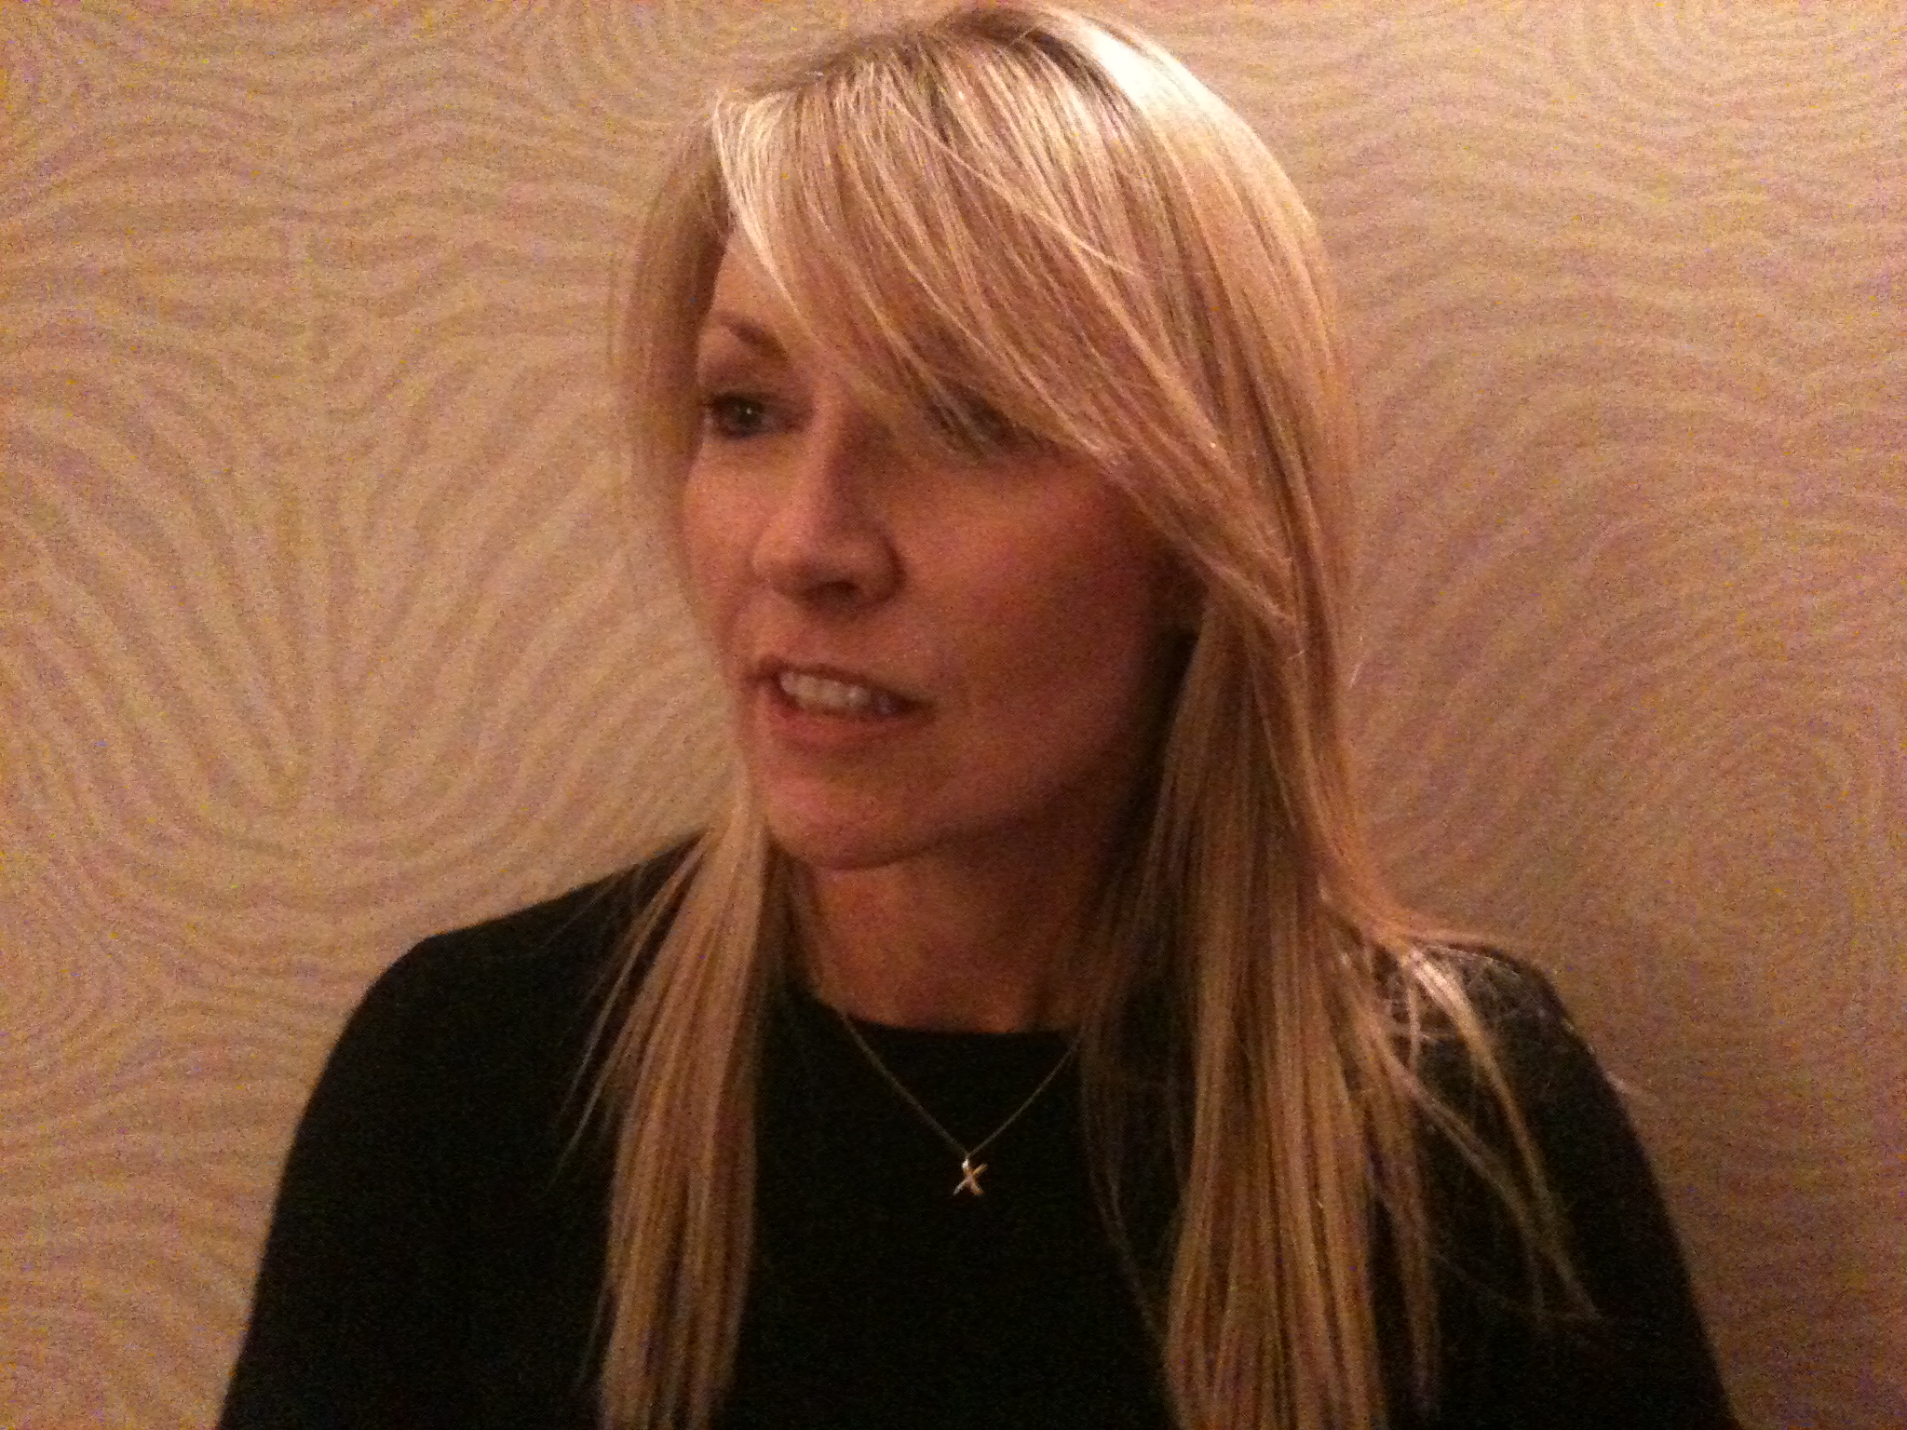
Sharon Quinn moved to Dittisham from London after a 30 year career in the
City, banking and finance sector. Dittisham residents and PPG colleagues are
very welcome to contact Sharon directly via ssharon9@aol.com

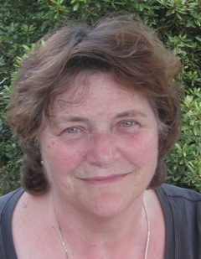
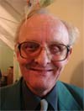
Rosemary Shiffner moved to Dartmouth in 1988 and now lives in Stoke Fleming. She worked for the Citizens Advice Bureau in Dartmouth then in Totnes for ten years. She says: ”We have such an amazing Health Service, which we all know is under pressure; everything we can do to ensure it works effectively will benefit each one of us! The PPG has been set up to provide a clear communication pathway for both the doctors and the patients”. Her contact email is: shiffner@tiscali.co.uk.
Steve Smith moved to Dartmouth in 1959 aged 7, married with six boys, manager of catering services at BRNC from 1979. Specialised in food and environmental hygiene, and health and safety. Founder Member of the Townstal Community Partnership, Chairman of the Townstal Community Hall Association since 2009 and a Town Councillor since May 2007 (Townstal Ward).
Steve may be reach at stevesmith625@btinternet.com .

