PPG Meeting

Minutes
January 30th

This meeting was called with a single item agenda – “The Plans for the Dartmouth Health and Wellbeing Centre”
Members attending: Ged Yardy (Chair Notes), Graham Ray, Nick Hindmarsh, Pierre Landel-Mills, Jonathan Hawkins, David Gent, Anita Cooper, Toni Blamey, Sharon Quinn DPC, John Donaldson BPC, Rokie Shifner, Diana Knight.
In attendance: Jess Pinder

- Graham Ray presented the HWBC plans.
The following are the points raised by the PPG for further review and consideration
- Include Natural lights / Roof lights on the first floor corridors
- Kid friendly feature/ play area
- Door from waiting room to toilet moved for privacy reasons to be adjacent to practice manager’s office
- Ensure disabled car access to all external doors HWBC and seek access on the East aspect of the HWBC.
- Paramedic/ Ambulance standby point considered – needs to be raised with SWASFT
- Consider moving pelican crossing on main road to give easier access to HWBC, nearer to path shown opposite Sainsbury’s - for elderly, mothers with children, etc.
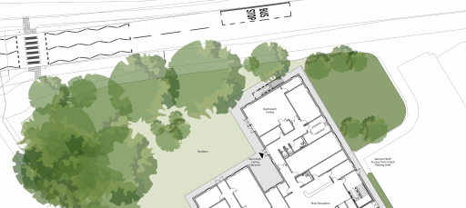
- Taxis likely to create congestion – consider drop by footpath in coach park
- Consider that the bus service could drop directly outside HWBC- Elderly and Kids
  - Parking configuration may need to consider this
  - Possible use of Coach Park where indicated for taxis
- Wheelchair/ equipment storage near entrance – as at TGH
- Reinstatement of drop off / deliveries / at rear as in earlier iterations of the plans
- Disabled places = 3 places, pls increase to 6 include and include mother and baby
- Maintain garden at rear
- Permanent Staff with reserved spaces can walk to their spaces – these do not need to be adjacent to the building in most cases – better to increase disabled spaces close to the entrance
- Parking:
  - One way system
  - Consider safer parking at an angle rather than 90⁰ eg Echelon parking
  - What size are parking bays? Consideration that cars are larger than they were
- Retain Eco build in particular seek provision for Solar panels, ground and air sourced heat pumps, wind
- Electric vehicle charging for 2 vehicles is a significant understatement of future demand – HWBC or SHDC issue?
- Build provision in for capacity for electrical charging points e.g. in 2030 50% of vehicles will be electric – HWBC or SHDC issue?
- Breakdown of costs for options that are rejected so that alternate funding possibilities can be evaluated

Copy to PPG members, Helen Elkington, Lesley Darke, Jonathan Hawkins SHDC

